**ONLINE TRANSFER PROCESS FLOW IN MEMBER UNIFIED PORTAL**

To file a transfer claim online, the member ID should be available in EPFO database and the employer should have registered the digital signatures of his authorized signatories with EPFO on the portal

Transfer will be working only for employee who have already uploaded their KYC in their portal, else first they can upload their KYC and same should approved by the employer through their Digital signature.

Once KYC got updated employee can carry out transfer

Before initiating the transfer process, employee should be ready with the following datas

* PF number & UAN with his/her previous Company
* DOJ & DOE of previous company should be updated

## Home-> Online services-> One Member – One EPF Account (Transfer Request)

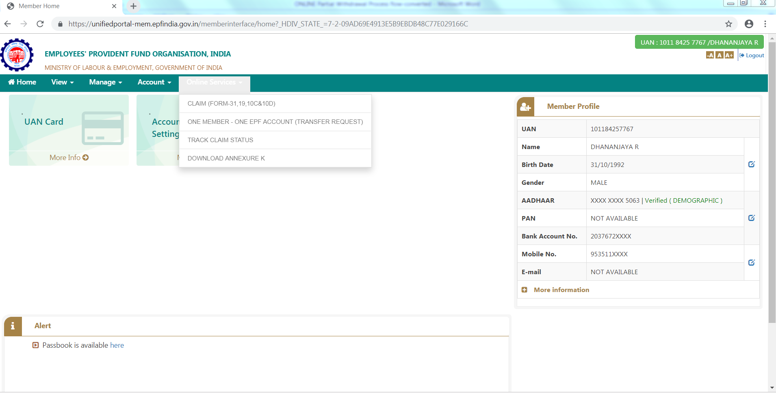

**Step: 1**

Pls read out the instruction before heading for transfer as follows

# Online transfer requests are accepted only when:-

* + KYC details are seeded against the UAN.
  + Only one transfer request against the previous member ID can be accepted.
  + If previous / present (Exempted) trust bank account and IFS code are available.
  + Please ensure that the personal information shown below is correct before proceeding with claim submission.

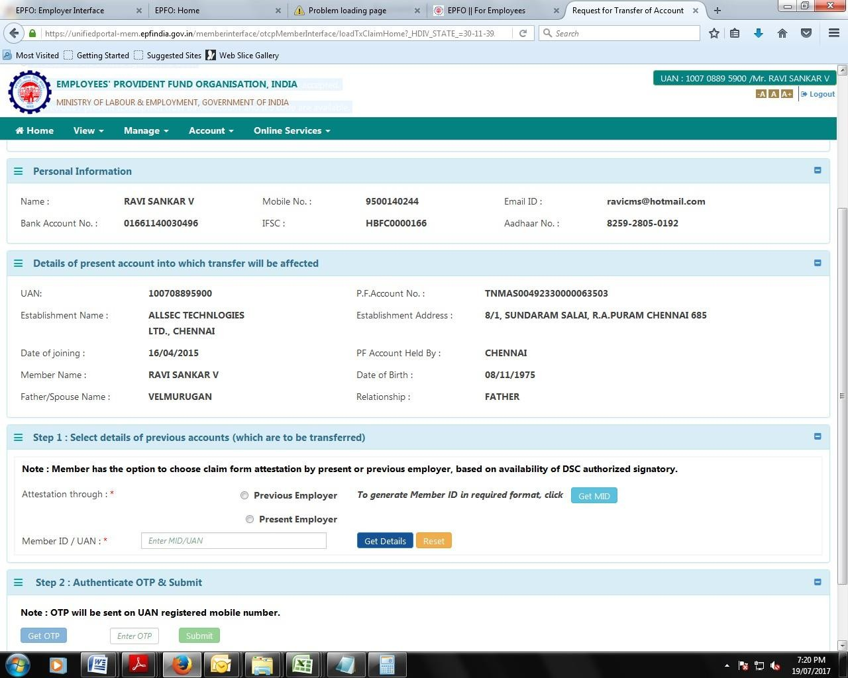

## C:\Users\7004091\Desktop\DEsk\REkha procesdd\snap\Transfer Nareesh.PNG

## Step: 6

* Select details of previous account/ Previous account
* Provide attestation rights to present Establishment / previous Establishment
* Enter UAN
* Click “Get OTP” and enter the OTP received on your registered mobile number
* click on “Submit”
* Save the transfer acknowledgement for future reference

## HOW TO CHECK TRANSFER STATUS

Once Transfer is submitted same will be rerouted to previous & present establishment for attestation Also you can view your transfer status in the below path

Member portal -> Home Page ->Online Services-> Track Claim Status



## You can view your transfer claim status on the below window.

